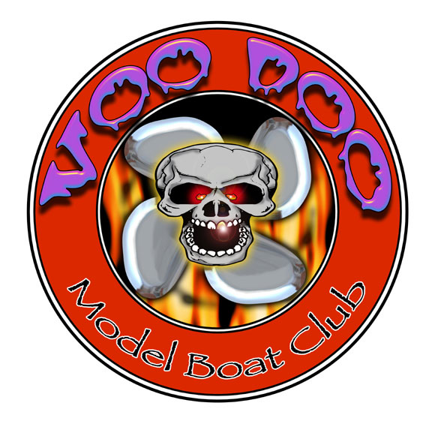
When: Nov. 18th-20th.

Where: VooDoo Lake 355 Airport Road. Reserve, Louisiana 70084

Fee: $25.00 First Boat, $10.00 Each Additional Class, No Limits

Contest Directors: Mike (MudBug) Hemric 336-602-5533
Jason Guhman 504-289-2515
Carlo Catalanotto 504-305-5005
Doug Dalme 337-280-3086

Racers Rep Jesse Lee 504-328-1825

Official Website: www.VooDooRCBoatClub.com

Classes: 5 Boats minimum to make class.

G-1 Sport Hydro
Open Sport Hydro (Any Gas engine up to 35cc)
Stock Mono (Stock Zenoah only with Canister 257 carb allowed)
G-1 Mono
Open Mono (Any Gas engine up to 35cc)
G-1 Cat
Open Cat (Any Gas engine up to 35cc)
G-1 Rigger
Open Rigger (Any Gas engine up to 35cc))
Thunderboat (Stock Zenoah only)
Crackerbox
Twin Gas Hydro
Jersey Skiff
Open Offshore ((Any Gas engine up to 35cc, Numbers, Drivers, Cowling and or Sponsors are required)
Gas Tunnel

Information: NAMBA Sanctioned, NAMBA Rules, Cards Will Be Checked
Open Water: Wednesday and Thursday Nov. 16th & 17th ,2010 —8:00 a.m. till Dark
or CD discretion.

Site Rules: No open water during trophy presentation after racing on Sunday.
Drivers meeting at 7:30 a.m.,first heat starts after drivers meeting.
NAMBA and VDMB rules of conduct will apply.

Trophies: 1st, 2nd & 3rd for classes with at least 8 boats if more than 10 boats
then 1st -5th will be awarded.

PayPal Payments: Voodooboatclub@yahoo.com

Mail Entries and
Make payments To: VooDoo Model Boaters 501 Bellview St. River Ridge, LA 70123

E-mail: voodooboatclub@yahoo.com

Rule deviations: Open Classes will be open to all NAMBA legal Electric, Nitro and Gas
Powered boats.

Event Itinerary: ***Pending Entries***
Friday 18th
Drivers Meeting 8am racing starts 15 minutes after conclusion of meeting.
Stock Mono
Crackerbox
Gas Tunnel
Jersey Skiff
Thunderboat
Twin Gas Rigger
Open Offshore
Jambalaya Feast

Saturday 19th
G1 Mono
G1 Cat
G1 Sport Hydro
G1 Rigger
Seafood Boil
VooDoo Party with Rock and Soul Live Band

Sunday 20th
Open Mono
Open Cat
Open Sport Hydro
Open Rigger
World Championship Awards Ceremony

Frequencies: First Received, First Assigned, We will call to clear conflicts

Entry Information
NAMBA/IMPBA Number
Name
Street Address
City
State
Zip code
Phone Number
Email

You must list alternate frequency.
Class | Frequency | Alt. Frequency | Fees
 |  |  | $25.00
 |  |  | $10.00
Total |  |  | $

Recommended Hotels

Quality Inn
3900 Highway 51. Exit 209 from I-10
Laplace, LA 70068
985-652-5544

Days Inn
3912 Highway 51. Exit 209 from I-10
La Place, LA 70068
985-652-1223
Hampton Inn
4288 Highway 51. Exit 209 from I-10
La Place, LA 70068
985-652-5002
Best Western Inn
4289 Main St.
La Place, LA 70068
985-651-4000

