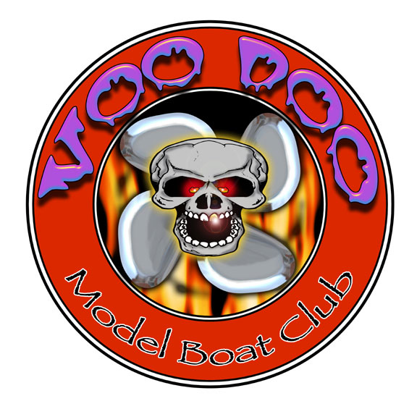

When: Nov. 16th-18th .

Where: VooDoo Lake 355 Airport Road. Reserve, Louisiana 70084

Fee: $25.00 First Boat, $10.00 Each Additional Class, No Limits

Contest Directors: Mark Grim
Jason Guhman
Doug Dalme
Carlo Catalanotto
Mike Hemric

Official Scorekeeper Kim Grim

Official Website: www.voodoogasworldchampionships.com

Classes: 8 Boats minimum to make class. (Some exceptions may apply)

G27 Sport Hydro
Open Sport Hydro (Electric, Nitro or Gas)
Super Sport Mono (Stock Zenoah only with Canister, Stock wt257 carb allowed)
G27 Mono
Open Nitro Mono
Open Mono (Electric, Nitro or Gas)
G27 Cat
Open Cat (Electric, Nitro or Gas)
G27 Rigger
Open Nitro Hydro
Open Hydro (Electric, Nitro or Gas)
Thunderboat (Stock Zenoah only, stock wt257 carb allowed)
Crackerbox
Twin Gas Hydro
G27 Jersey Skiff
Open Offshore (Electric, Nitro or Gas, Numbers, Drivers, Cowling and or Sponsors are required)
Specialty Classes: Gas Tunnel, Team Marathon, Nitro Twin Shootout

Information: NAMBA Based Rules, Cards Will Be Checked. IMPBA
Members will be allowed to purchase NAMBA Insurance for an additional
$10.

Open Water: Monday thru Thursday Nov. 12th - 15th ,2012 —8:00 a.m. till Dark
or CD discretion.

Site Rules: No open water during trophy presentation after racing on Sunday.
Drivers meeting at 7:30 a.m.,first heat starts after drivers meeting.
NAMBA and VDMB rules of conduct will apply.

Trophies: 1st, 2nd & 3rd for classes with at least 8 boats if more than 10 boats
then 1st -5th will be awarded.

PayPal Payments: Voodooboatclub@yahoo.com

Mail Entries and
Make payments To: VooDoo Model Boaters
1905 34th Street.
Kenner, LA 70065

E-mail: voodooboatclub@yahoo.com

Rule deviations: G27 classes will allow any style gas engines with any
combination of bore and stroke up to 27cc. Open classes will include
Electric, Nitro and all Gas powered NAMBA legal hulls.

Frequencies: First Received, First Assigned, We will call to clear conflicts
Entry Information
NAMBA/IMPBA Number
Name
Street Address
City
State
Zip code
Phone Number
Email

You must list alternate frequency.
Class | Frequency | Alt. Frequency | Fees
 |  |  | $25.00
 |  |  | $10.00
Total |  |  | $

Host Hotel (Please try to use host hotel as your first choice as they take care of us for all of the races)

Quality Inn
3900 Highway 51. Exit 209 from I-10
Laplace, LA 70068
985-652-5544

Host Hotel Information:
Quality Inn in Laplace Is 9 miles or approximately 12 minutes from the pond and they have given us a rate of 79.99. The Rate also includes a hot Buffet style breakfast (Eggs,Sausage, etc.) each morning from 5am til 9am. Normal rates for this hotel are between 99.99 to 129.99. Just let them know that you reserving rooms for the VooDoo race to get the racers rate.

Other Hotels

Days Inn
3912 Highway 51. Exit 209 from I-10
La Place, LA 70068
985-652-1223
Hampton Inn
4288 Highway 51. Exit 209 from I-10
La Place, LA 70068
985-652-5002
Best Western Inn
4289 Main St.
La Place, LA 70068
985-651-4000

